06 December 2013

Our Ref: 2013/049

Dear Parent/Carer

**Year 12 Progress Report**

Please find enclosed the first of at least four Progress Reports that you will receive as part of your child’s Post-16 education. Using data collected from the student’s learning tutors we report to parents twice a year giving students, their Personal Tutors and Parents/Carers a clear indication of progress and effort across their programme of study. You have already received individual targets for all subjects which have been set, taking into account the student’s prior attainment.

Yours sincerely

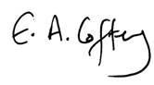

Mrs E A Coffey

Principal

Enc.