BTEC Art and Design

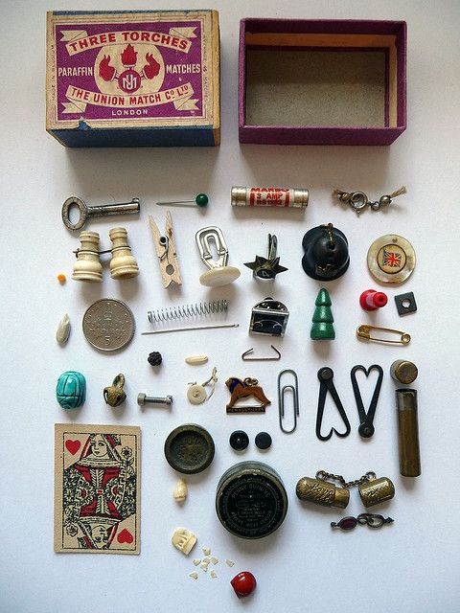
Task One
Your first task is to obtain a small box / tin and fill this with random objects. This could be a matchbox, an old sweet tin or anything that will hold these bits and bobs together. These objects need to be small so you can collect lots of odd, random items. This actual collection will need to be brought with you for your first sessions with EO as this will form part of your first session

Task Two
Secondly, take a series of photographs of all these bits and bobs arranged outside of the box/tin. Organise these in a creative way and consider the angles that you capture these photographs. You will need 4-6 photographs that have been printed onto photographic paper. Boots, ASDA and other large supermarkets provide this service.

Task Three
Finally, you are then required to produce one detailed drawing of this whole arrangement or a series of individual drawings of selected objects. You are required to spend a minimum of an hour on this drawing task.
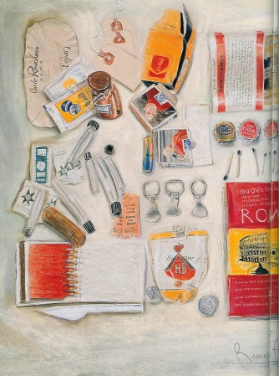
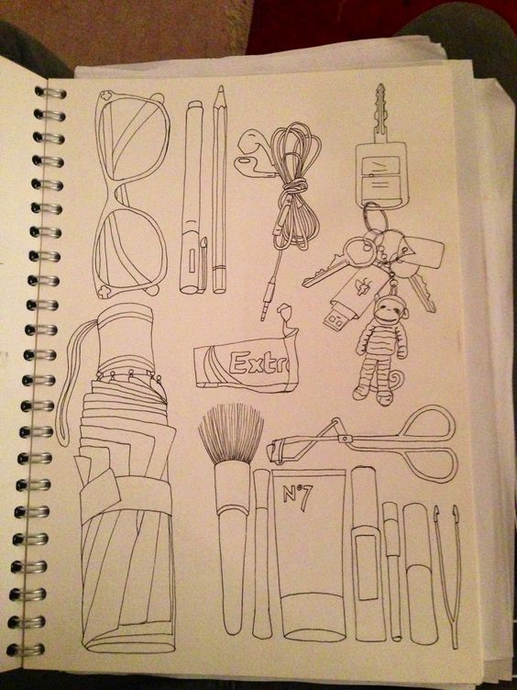

Feel free to hand in this completed work prior to or bring this to your first BTEC session with EO

