A Level English Language and Literature
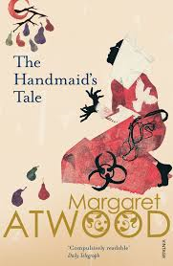
After the initial induction period of the English Language and Literature course, you will begin studying the dystopian novel The Handmaid’s Tale by Margaret Atwood.
It is vital that you understand the themes and ideas that Atwood conveys through her writing.

Your Task
Over the remainder of the summer holiday we would like you to produce a short presentation on dystopian societies in literature.
You can use a variety of techniques to present to ensure that your presentation is interesting! In the past, groups have performed drama, dance, news reports, puppet shows, or quizzes. For example you could ‘interview’ authors, or perform examples of their writing. The more original the better!

