A Level English Literature
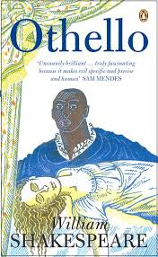

After the initial induction period of the English Literature course, you will begin studying the tragic play Othello by William Shakespeare.

It is vital that you understand the themes and ideas that Shakespeare conveys through his writing.

Your Task
Over the remainder of the summer holiday we would like you to produce a short presentation on tragedy in literature.
You can use a variety of techniques to present to ensure that your presentation is interesting! In the past, groups have performed drama, dance, news reports, puppet shows, or quizzes. For example you could ‘interview’ authors, or perform examples of their writing. The more original the better!

